HTML File Paths

📘 Definition
# Source: AI Source: Provided by: [Data Path: Persons Table -> ID Column: 1, Name_En Column: Motasem Essam] -> From: [ChatGPT] on [5/6/2026]
An HTML file path is the way you locate and connect files (like images, CSS, JavaScript, videos) inside a website.
It tells the browser where to find a file.

🌐 Types of File Paths
# Source: AI Source: Provided by: [Data Path: Persons Table -> ID Column: 1, Name_En Column: Motasem Essam] -> From: [ChatGPT] on [5/6/2026]
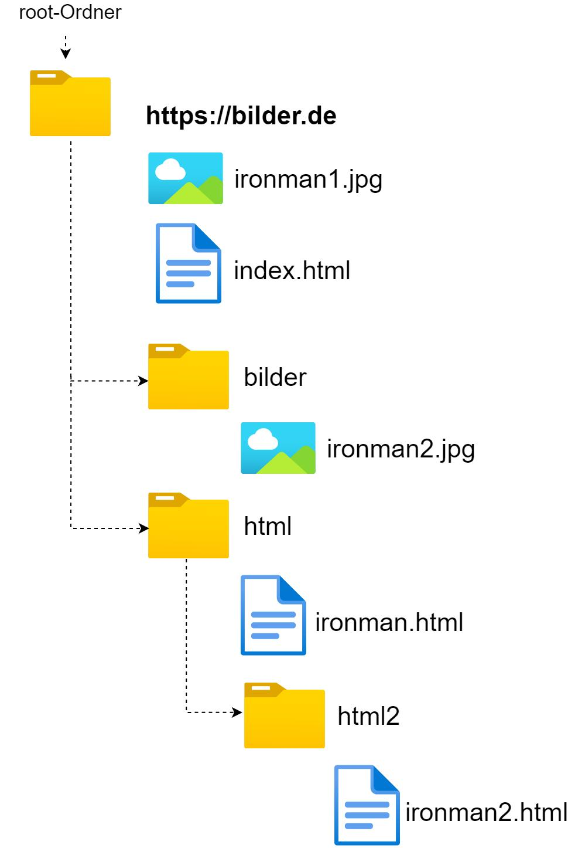
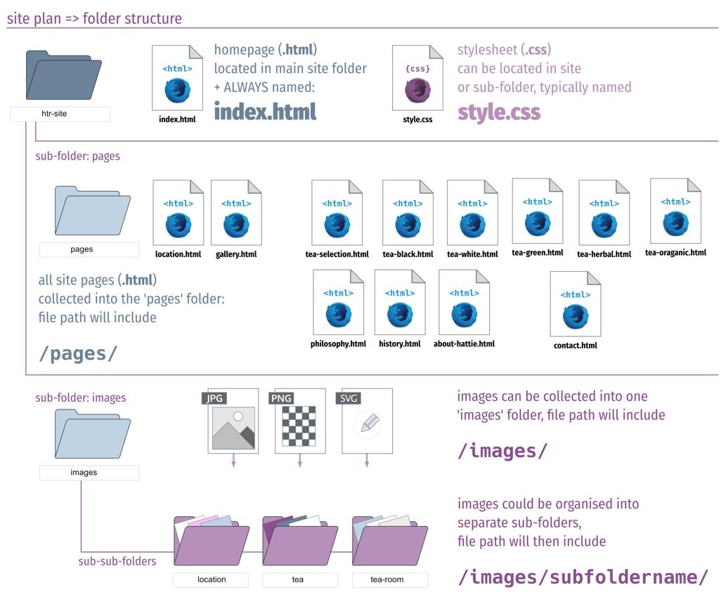
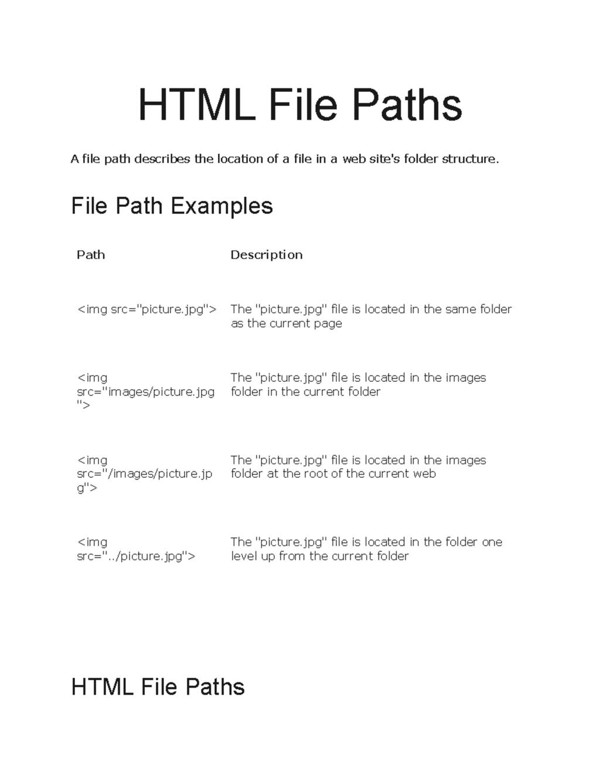

🌍 1. Absolute Path
# Source: AI Source: Provided by: [Data Path: Persons Table -> ID Column: 1, Name_En Column: Motasem Essam] -> From: [ChatGPT] on [5/6/2026]
📖 Description
A full URL that includes the entire address of the file.
💻 Example:
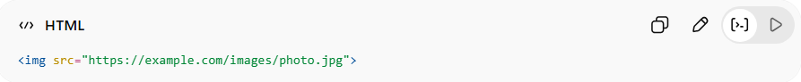
<img src="https://example.com/images/photo.jpg">
✔ Works from anywhere
❌ Depends on internet/server

📁 2. Relative Path
# Source: AI Source: Provided by: [Data Path: Persons Table -> ID Column: 1, Name_En Column: Motasem Essam] -> From: [ChatGPT] on [5/6/2026]
📖 Description
A path based on the current file location in your project.
💻 Example:
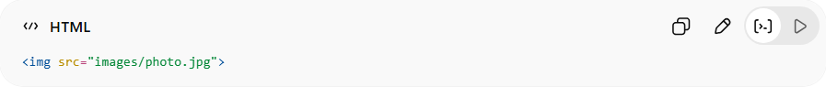
<img src="images/photo.jpg">
✔ Common in real websites
✔ Works inside same project

🏠 3. Root-Relative Path
# Source: AI Source: Provided by: [Data Path: Persons Table -> ID Column: 1, Name_En Column: Motasem Essam] -> From: [ChatGPT] on [5/6/2026]
📖 Description
Starts from the root of the website using /.
💻 Example:
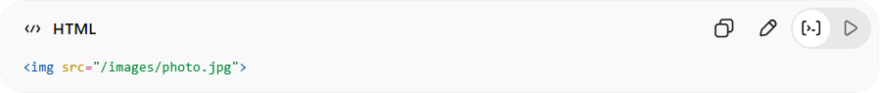
<img src="/images/photo.jpg">
✔ Always starts from website root
✔ Useful in large websites

🔙 4. Parent Directory Path
# Source: AI Source: Provided by: [Data Path: Persons Table -> ID Column: 1, Name_En Column: Motasem Essam] -> From: [ChatGPT] on [5/6/2026]
📖 Description
Moves one folder up using ../
💻 Example:
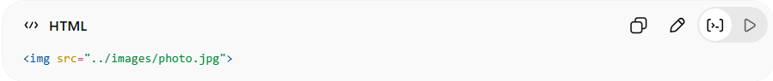
<img src="../images/photo.jpg">
✔ Goes up one folder level

📂 5. Current Folder Path
# Source: AI Source: Provided by: [Data Path: Persons Table -> ID Column: 1, Name_En Column: Motasem Essam] -> From: [ChatGPT] on [5/6/2026]
📖 Description
Refers to files in the same folder.
💻 Example:
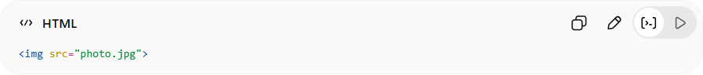
<img src="photo.jpg">
✔ No folder name needed

⚙️ Example Folder Structure
# Source: AI Source: Provided by: [Data Path: Persons Table -> ID Column: 1, Name_En Column: Motasem Essam] -> From: [ChatGPT] on [5/6/2026]
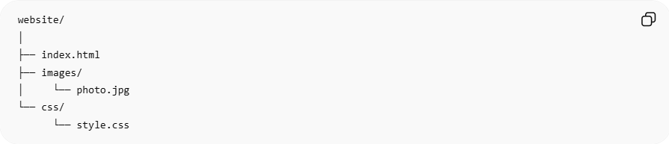
website/
│
├── index.html
├── images/
│ └── photo.jpg
└── css/
└── style.css

🧠 Example Usage
# Source: AI Source: Provided by: [Data Path: Persons Table -> ID Column: 1, Name_En Column: Motasem Essam] -> From: [ChatGPT] on [5/6/2026]
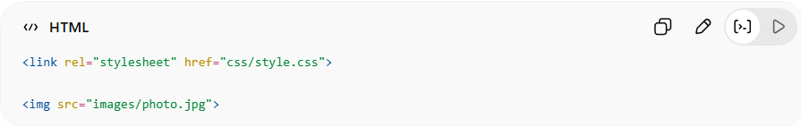
<link rel="stylesheet" href="css/style.css">
<img src="images/photo.jpg">

⚠️ Common Mistakes
# Source: AI Source: Provided by: [Data Path: Persons Table -> ID Column: 1, Name_En Column: Motasem Essam] -> From: [ChatGPT] on [5/6/2026]
❌ Wrong Path
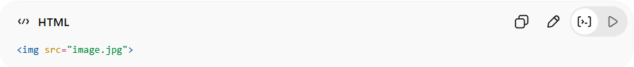
<img src="image.jpg">
👉 File is inside /images/ folder → won’t load
✅ Correct Path
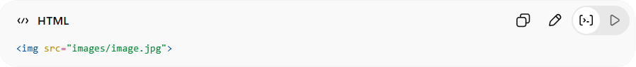
<img src="images/image.jpg">

🚀 In short:
# Source: AI Source: Provided by: [Data Path: Persons Table -> ID Column: 1, Name_En Column: Motasem Essam] -> From: [ChatGPT] on [5/6/2026]
HTML file paths tell the browser where to find files like images, CSS, and JavaScript inside a website structure.

